
Company
Logotype

Cone Beam Computed Tomography- Report



Porur Dental X-rays & CBCT

Patient Name : Mrs. Banupriya | Date of Report : 05.11.2024
Age/ Gender : 29 years/ Female | Region of Interest : CBCT Sectional Maxilla
Referring doctor: Thamara Dental | Indication : Assessment of 17
Clinical Notes: Nil
PATIENT INFORMATION

CBCT- Sectional Maxilla provided
CBCT – IMAGE DETAILS

RADIOGRAPHIC INTERPRETATION

- In relation to 17, hyperdense restorative material in the pulp chamber, extending into the Mesio-buccal and palatal root canal upto the apical third is evident.
- In 17, immediately distal to the mesio buccal root canal, presence of 2 small hypodense accessory canals, that appears to extend upto the apical third of the mesial root is evident.
- The alveolar bone in relation to the maxillary alveolar ridge is present with normal trabecular pattern.
- The right maxillary sinus is present with mucosal thickening in relation to its floor.

RADIOGRAPHIC IMPRESSION

- Partially Root canal treated tooth: 17 with accessory canals.
- Right maxillary sinusitis.

Kindly correlate with clinical findings


IMAGES FOR REFERENCE

RECONSTRUCTED PANORAMIC VIEW

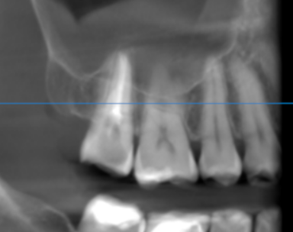

3-DIMENSIONAL VIEW

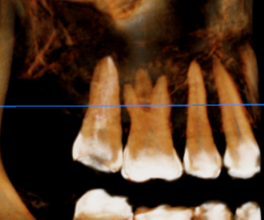

CORONAL VIEW

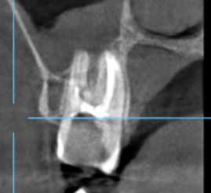

MULTIPLANAR VIEW
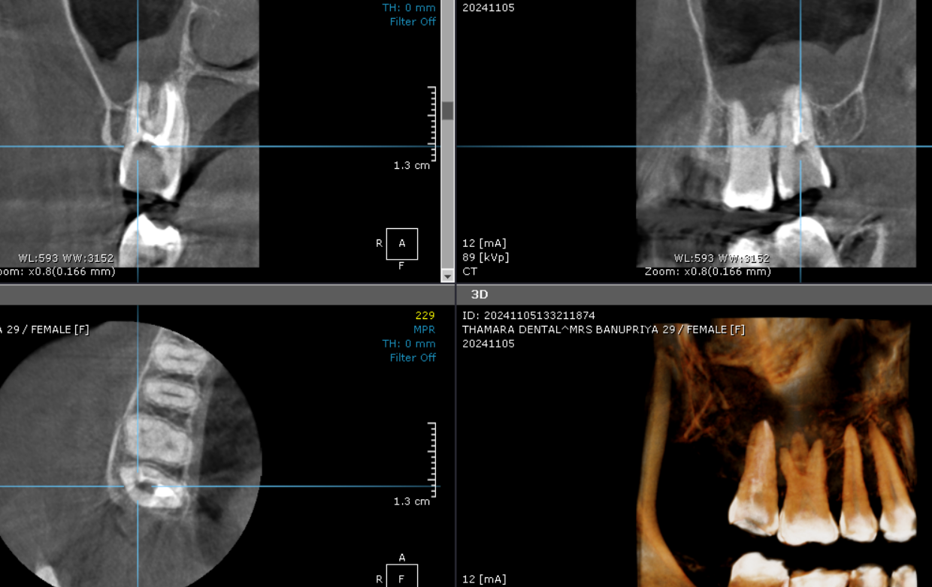

**** End of report ****

